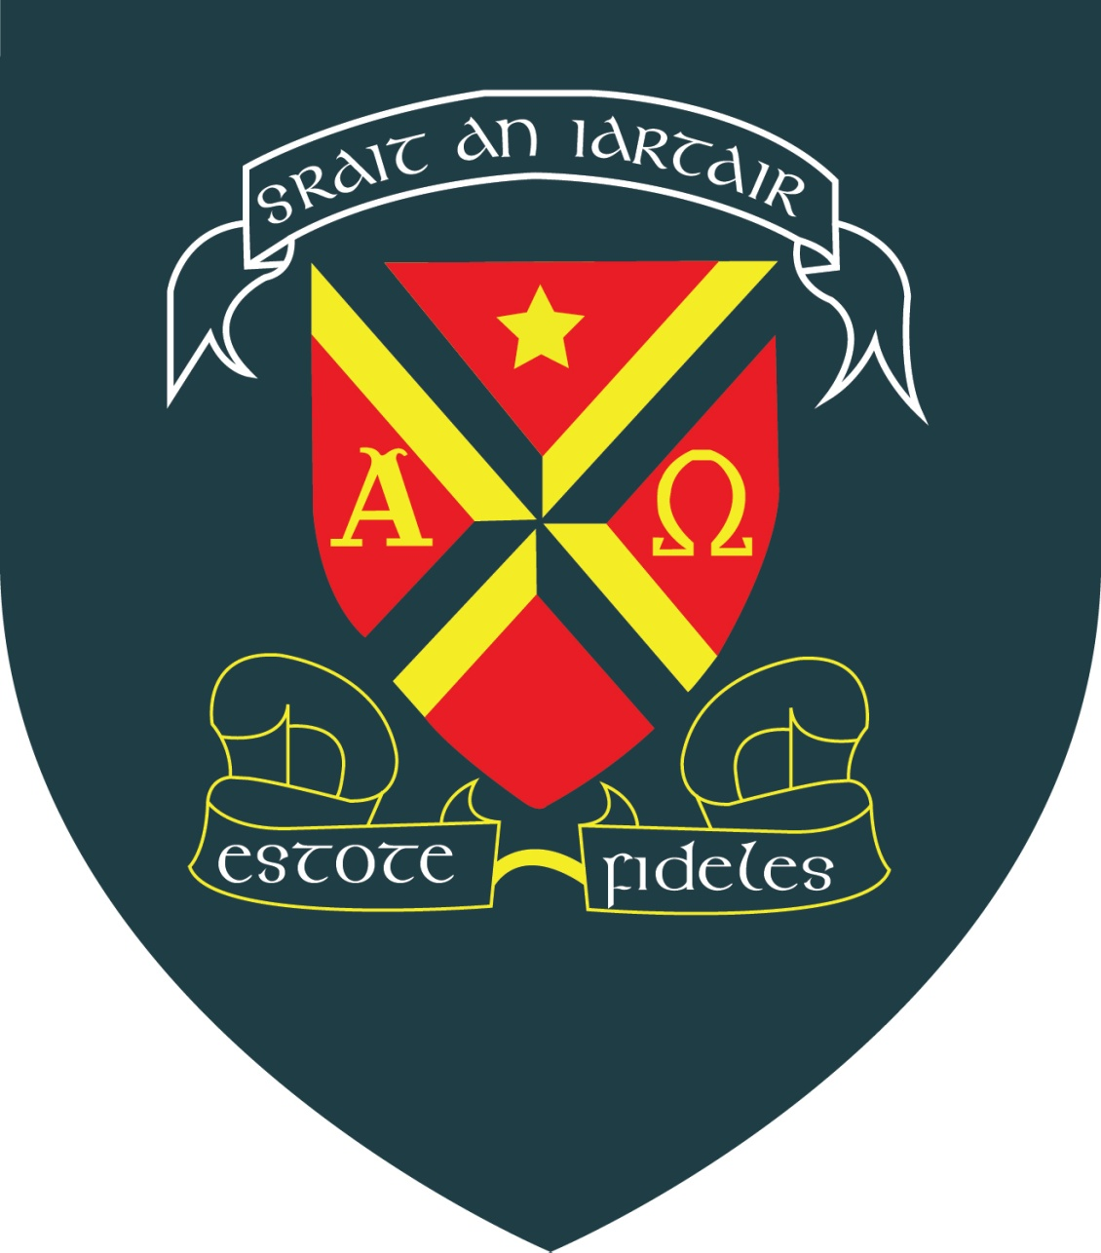

C.B.S. Westland Row School
Museum Launch
The Leaving Cert Applied 5th year class are proud to invite you to the grand re-opening of the C.B.S Westland Row School museum.
All artefacts have been renovated, reframed and placed in a timeline of chronological order on the second floor of the school. We would love you to join us to open and view the museum, and then join us for some light refreshments afterwards on January 27th at 12pm in C.B.S. Westland Row School.
Please rsvp
info@cbswestlandrow.ie
pho:01-6614143

